Observational Problem
Main Telescope
- Point your telescope to NGC 6475
RA (J2000): 17h 53m 54s
Dec (J2000): -34º 49”
Validate your object to your telescope assistant. (20 points)

- Write down the cardinal direction (North, South, East and West) on Chart 1 in the answer sheet. (10 points)

- Find 3 missing stars on Chart 1 based on the object you have observed. Mark the position of the missing stars with crosses (X). (25 points)

- Given that the magnitude of star A, B and C are 7.6, 7.2, and 5.6 respectively. Estimate and write down the magnitude of the missing stars beside each mark you have given.
(20 points)

- Estimate the FOV of the eyepiece in this observation, stopwatch provided. Show your calculation in the answer sheet. (25 points)

Main Telescope Anwer Sheet

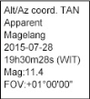
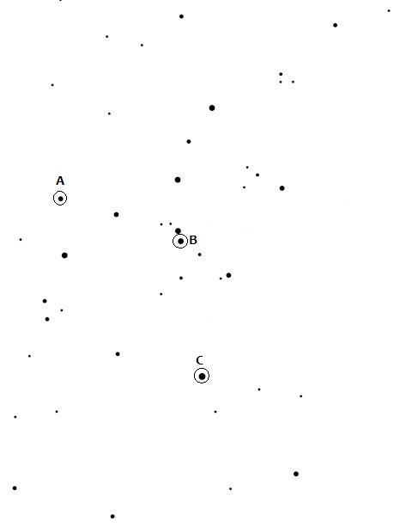
Chart 1

